Exercise 1

Job Provider - jobs list ,remove, add

Job List screen:
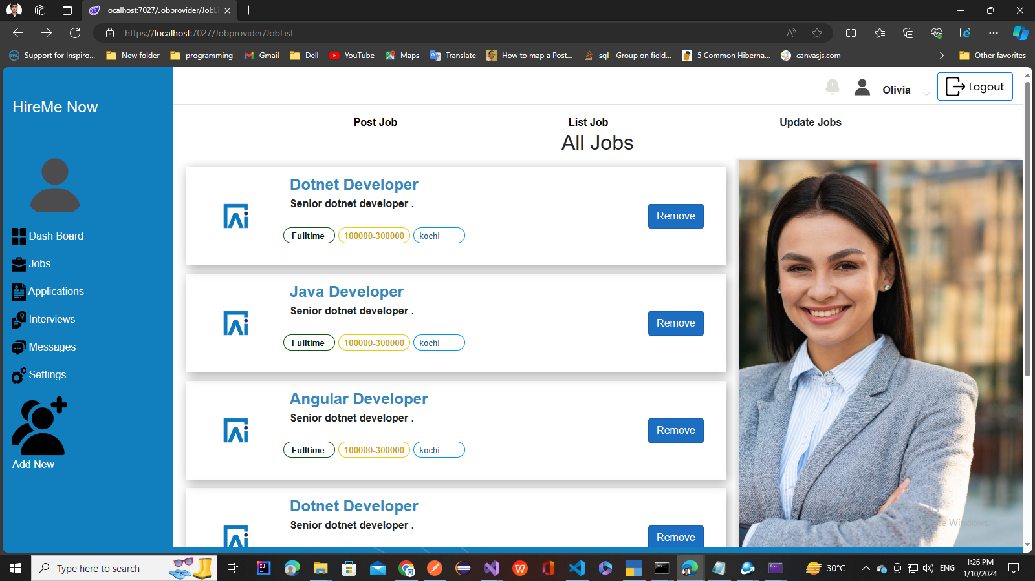

Add Job Screen:
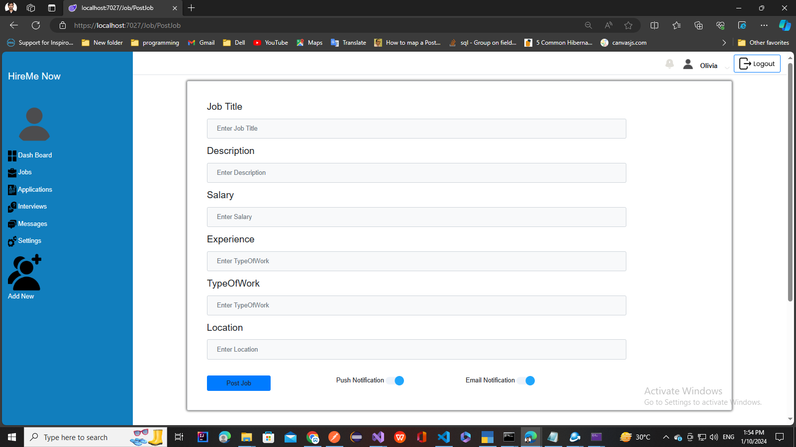
Features to implement:

- Create Job List page to List Jobs from a list of jobs
- Create Add Job Component to add job
- Implement the Create job functionality to add jobs to the list

